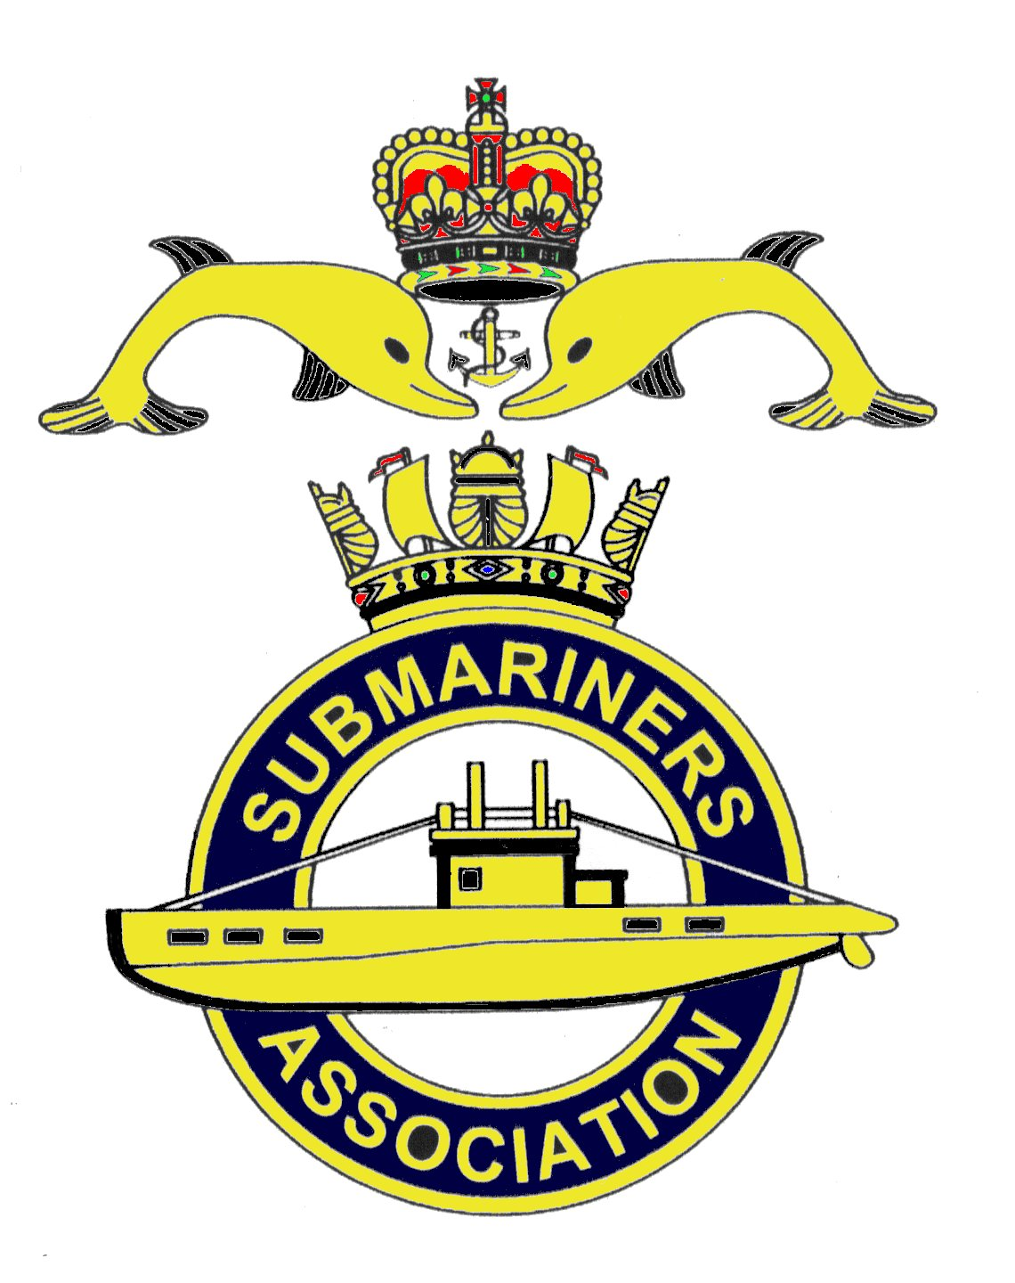  Lincoln Branch | Minutes of Monthly meeting and AGM of Lincoln Submariners Association  At  The RNA Club 26th May 2019

- The Chairman opened the meeting at :- 1235

- Members present :- There were 9 members present.

- Apologies:- Were received from, D.Bussey, A.Last, P.Langdon-Manning .R.Elrick R.Frankish ( In France at Lochnagar) A.Jeffrey ( Edinburgh running marathon). T.Eynon (Recovering from hernia op)

- Obituaries: "In Memorium" sheet was passed round for all to read, during which a minutes silence was
held for those that have crossed the bar, followed by our prayer.

- Minutes of the last meeting: The minutes of the last meeting were accepted as a true record.
- Matters arising: There were no matters arising.

- Chairman’s Report:-
1) CASD 50 - 1st Sea Lord's speech given at the at Westminster Reception on 3rd May 2019.
A copy of this is attached together with examples of the First Day covers to commemorate CASD 50.
Details on how to purchase these First Day covers is shown on attachment.
2) R&C of S.A. - Pocket edition.
The Chairman has produced a pocket size edition of the" Rules and Constitution of the Submariners
Association". Copies were handed out to all members attending the meeting.

8. Correspondence:
1) A request received from the Membership Secretary, David Woolterton, asking if the
Lincoln Branch have any knowledge about two past members of this branch. David is trying to update the
Database of members. The two concerned are:- Bunts Burdall and Rusty Gates. Gents if anyone can
provide any information on these two, will you please let me know.
2) 2020 Diaries will soon be available for ordering, the cost will be £2 per diary. A list will be
made at future meetings, by the secretary with a closing date of October,
3) CASD 50 pins. The pins ordered for members have now been received. A cheque for
payment has been sent to Brian Tate ( Secretary of the West of Scotland Branch )

9. Secretary's Report:-
1) Nothing to report.

10. Treasurer's report:-
Prior to this report the Chairman reported that the accounts had been audited and correct. As in the past,
this has been done by R.Elrick. The secretary questioned the legality of having the audit done by a member of
the branch. The secretary's comments were noted by the chairman.
Monthly Statement 14/04/2019
Opening Balance £2,619.38 Monies Paid out last month
Meeting collection £47.00 Flowers for B.Hunter £25.00
Branch Balance £2,641.38
Meeting Collection 26th May £32.80

11. Social Secretary:-
1) Chatham visit. A very enjoyable trip, with thanks given to the Social Secretary from
J.Horton, M.Williams and J.Hobson for a well organised event.
2) Christmas Dinner. There are still members that are going but have not given their menu
choices to the Social Secretary. Will these members please update the S.S.
3) Future visits and Lunch Club. The acting Social Secretary said that either he or the new
social secretary will look into this at a future date when there are more members present.

12. Welfare:- There were no welfare reports requiring attention.

13. Standard Bearers Report:- Members were reminded that the 75th Anniversary D Day celebrations will
take place on Thursday 6th June at the War Memorial, High St, Lincoln. Muster at 1030. Standard will be
paraded.

14. AOB:-
It was decided that as the Sunday of our June meeting is "Fathers Day". Moving the date to the
following Sunday was not an option due to bookings within the Social Club. Therefore June's meeting
is cancelled and our next meeting will be on Sunday 21st July 2019.

M.Williams reported that there will be an AFD collection on Saturday 1st June. Volunteers to
muster at the War Memorial, Lincoln High St at 0900. The previous collection day realised £1.089. Funding
has been received from the MOD for £2000.
AFD LINCOLN IS ON SATURDAY 29TH JUNE 2019 VOLUNTEERS ARE REQUIRED TO MAN THE
STALL. ETC. More details to follow when known.

The meeting was shut at 1252

NEXT MEETING SUNDAY 21st July 2019

Please be advised that these notes of the meeting by the secretary cannot in any way be regarded as the
official minutes until they are approved and accepted at the meeting.

AGM 26th MAY 2019 opened at 1253

Annual Statement of accounts.
Credit for year 2018/2019 £3,693.94
Debit for year 2018/2019 £1,052.56
Balance carried forward £2,641.38

Income for year 2018/2019 £5,631.04
Expenditure 2018/2019 £2,989.66
Balance carried forward £2,641.38

Standard Bearers Report:-
Your standard was paraded since our last AGM as follows:-
a) AFD June 2018, Lincoln
b) Funeral of Malcolm Flowers 9th July 2018
c) Trafalgar Night 21st October 2018
d) Memorial Service, Victoria Embankment, London. 4th November 2018
e) Concert of Remembrance, Robert Patterson School, N.Hykeham. 9th November 2018
f) Service of Remembrance, War Memorial, High St, Lincoln. 10th November 2018
g) Funeral of Barry Stoham (ex FAA) Lincoln Crematorium. January 2019
h) S.A.Annual Reunion, Holiday Inn Hotel, Leicester. 24th March 2019
i) Funeral of Rev M. Chapman.

ELECTION OF OFFICERS

a) Chairman F.Powell
b) Vice Chairman M.Brockelsby
c)Treasurer D.Shaw
d)Secretary D.Willcock (Temp)
e)Social Secretary F.Powell (Temp)
f)Welfare Rep. As agreed at the 2017 AGM, we all act as Welfare Reps.
g) Standard Bearer D.Willcock

THE AGM WAS SHUT AT 1310.

